Town of Hanson, Massachusetts
Community Preservation Committee
Town Hall - 542 Liberty Street, Hanson, MA 02341
781-293-5644 Ext 102
PROJECT FUNDING APPLICATION COVER PAGE
Chairperson: Laura FitzGerald-Kemmett, At-Large
Kenneth Mitchell, Parks and Fields Commission Patty Norton, Historical Commission
Allan Clemons, Historical Commission Robert Overholtzer, At-Large
Joseph Gamache, Planning Board Commission Robert Sears, Housing Authority
John Kemmett, Conservation Commission Thomas Hickey, At-Large
ASSURANCE:

I _________________________________ hereby certify under the penalties of perjury that the following application
(Print the name of the fiduciary agent)
information is true and correct to the best of my knowledge and that I am legally able to enter into a contract on behalf of
_________________________________________ with the Town of Hanson for Community Preservation Funds.
(Print the name of the contracting agency)
Signature: ___________________________________________________ Date: ____________________________
(Sign in blue ink by the fiduciary agent)
Title: _________________________________________________________________________________________

Project Name: __________________________________________________________________________________

Address: ______________________________________________________________________________________

Telephone: _______________________ (home) _______________________ (work) ______________________ (cell)

Email Address: _________________________________________________________________________________

Amount of CPA Funding Requested: ______________________________________________________________

Note: Before a final award is granted, the project proponent will be required to verify that the information in this submission is true and correct. Supplemental/supporting documentation, such as attested copies of recorded deeds or restrictions or corporate papers, may be required at the discretion of the CPC.
1
Town of Hanson, Massachusetts
Community Preservation Committee
Town Hall - 542 Liberty Street, Hanson, MA 02341
781-293-5644 Ext 102

PROJECT FUNDING APPLICATION
(Submit a completed original application along with nine (9) hard copies on or before 12/15)
The following excerpt from the Community Preservation Act (CPA) describes the types of projects that are eligible for CPA funding:
The Community Preservation Committee shall make recommendations to the Town Meeting for the following:
- For the acquisition, creation and preservation of open space;
- For the acquisition, preservation, rehabilitation and restoration of historic resources
- For the acquisition, creation and preservation of land for recreational use;
- For the rehabilitation or restoration of open space, land for recreational use and community housing that is acquired or created as provided in this section.
- With respect to affordable housing, the Committee shall recommend, wherever possible, the reuse of existing buildings or construction of new buildings on previously developed sites.
Town of Hanson, By-laws Article 2-20, Community Preservation Committee.

All proposal proponents must begin by submitting a pre-application form which will be reviewed and commented upon by the Community Preservation Committee (CPC). Upon pre-application approval, an application form must be completed in full land submitted in accordance with any CPC established time lines. The CPC will use the scoring criteria defined on Appendix Page H to rate the proposals before the CPC and receives a majority vote of support from Town Meeting and certification by the Massachusetts Attorney General and Department of Revenue.

The applicant’s narrative project description should include a discussion of the following:
- Project description,
- Project plan,
- Current ownership and existing restrictions,
- Value of property involved,
- Project costs,
- Proposed ownership/restrictions after the project completion.

If this project will leverage additional fund (e.g., be used a ‘match’ for other grand funds) or will be repaid with earned income in the future, please describe those provisions in full.

Projects will be recommended for funding based on the merits of both the proposal and the project and the proposed costs of the project when compared to the merits and proposed costs of competing proposals. All recommendations and actual awards are subject to the availability of CPA funds.

NOTE: Project proposals that address more than on CPA eligible purpose; leverage additional funding, involve the collaboration of more than one agency, organizations, board or committee; or otherwise show a comprehensive, community centered, multidisciplinary approach, will be given highest consideration.

See CPA definitions (Appendix page A) and Project Election Criteria (Appendix page C) for more information.

2
Once a project proposal has been submitted, the applicant and his/her agent(s) are forbidden to speak with or “lobby” any CPC member about that proposal. Such a prohibition includes questions about the proposal or the proposal process, any attempt to give unsolicited additional information or seek information about the grant making process. After the submission of a proposal, any and all questions must be addressed to the Committee Chair only. The Chair will post questions and their answers on the Hanson town website /Community Preservation Committee page so all applicants will have equal access to information.

Speaking to any other member of the CPC after the grant making process has begun will result in the applicants’ proposal being rendered non-responsive and eliminated from consideration.

For Hanson Town Government submissions only:

If this application is being submitted for work to be done by a Department of Hanson government, it must include assurances that the following entities have approved its submission.

The undersigned support and approve the application and budget included herein:

_________________________________________________________________
Department, Printed name of the Department Head Signature Date

__________________________________________________________________________________
Printed name of Hanson Town Counsel Signature Date

__________________________________________________________________________________
Printed name of Hanson Procurement Officer Signature Date

__________________________________________________________________________________
Printed name, Chair, Hanson Board of Selectmen Signature Date

Thoroughly answer each of the following questions using additional paper as necessary.
A. Project Description/Eligibility for CPA funding

- Which community preservation purpose does this project address? Use the Community Preservation Fund Allowable Spending Purposes chart provided on Appendix page G of this packet as a guide.

Check all that apply:

o Community housing
o Historic resources
o Open Space
o Active recreation
o Passive recreation
o Explain exactly how your project acquires, creates, preserves, supports, rehabilitates or restores according to the criteria defined in chart 1 on Appendix page G.

2. State the project’s official name and include any of the following that are necessary or appropriate: (a) street address of the project; (b) assessor’s map and lot number(s); (c) current ownership; (d) existing use or deed restrictions; (e) proposed ownership after project completion; (f) proposed use or deed restrictions after project completion (including proposed conservation, open space, recreation, historic and affordability restrictions).
_____________________________________________________________________________________________________________________________________________________________________________________________________________________________________________________________________

3
3. Proposal narrative: Limit: 3 pages excluding Memoranda of Agreement (MOA’s2). Using additional sheets of paper, thoroughly describe the history, purpose and present mission of the applicant organization, the proposed project; a time-task plan for the project; task management plan; the way(s) in which the proposed project is compatible with Community Preservation goals, why the project will benefit Hanson, how the project will add “public value” to Hanson (this is particularly necessary for private, non-profit applicants), and any other facts or considerations you feel are pertinent to this project’s successful application.
B. Considerations for funding

1. Does the project serve a need or goal set forth in the Town of Hanson’s Master Plan, Open Space and Recreation Plan or other planning document(s) related to community preservation?

Master Plan: Yes _______ No_______ If yes, please explain

Open Space & Recreation Plan: Yes ____ No_____ If yes, please explain

Other: Yes ________ No______ If yes, please explain

Provide letters of support of MOA’s from the Boards/Committees to support the inclusion of this proposed project in their overall goals.

2a. What is the total project cost? “Total project cost” is defined as the amount requested from the CPA in addition to any other public or private funds which will be invested.

a. CPA funds requested =$___________________

b. Private funds invested =$___________________(define source in 2d)

c. Public funds invested =$____________________(define source in 2d)

d. Other investments =$____________________(define source in 2d)

Total project cost =$____________________(sum of lines a through d)

2b. Fully describe and support the requested funding (e.g., financial quotes, estimates, comparative analysis with a similar project, etc.). Details of the funding request should be reserved for the Budget Narrative. This section should explain with what process and from whom the quotes, estimates, comparative analyses, etc. were acquired.

2c. Will CPA funds leverage or supplement other funding for this project? (i.e. self-help grants/ matching grants/private contributions)

Yes_____ No_____ If yes, please explain:

_____________________________________________________________________________________________________________________________________________________________________________________________________________________________________________________________________

2d. For any source of funding other than the CPA, list the name of the funding source and the date(s) that those funds will be available: _____________________________________________________________________________________________________________________________________________________________________________________________________________________________________________________________________

3a. Proposed project start date: ________________________________________________________

3b. Projected completion date (or length of time from start until completion) ________________________
4
Note: Projects are expected to begin within 6 months of receipt of funding (after town meeting certification by the Attorney General). If a project has shown no action within 12 months after town meeting certification, the award will be considered void and another application must be made to receive CPA funding.

- Attach letters of support or MOA’s from relevant town boards or committees (e.g., Conservation Commission, Recreation Commission, Historical Commission, Historic District Commission, Hanson Housing Authority, Hanson Housing Partnership, Master Plan Implementation Committee, Board of Selectmen, etc.) Letters/MOA’s must explain why the proposal is considered beneficial to that specific board/committee or commission.

It is the responsibility of the applicant to gather support letters and MOA’s and submit them with the application. No support letters or MOA’s may be submitted after the application deadline. Applications not accompanied by either MOA’s or support letters will be considered non-responsive and not reviewed for funding. Electronic submissions must include MOA’s or letters of support on electronic letterhead from the originating Board/Committee. Electronically submitted letters of support or MOA’s may be submitted unsigned if the applicant is not able to scan them for submission.
List attached letters or MOA’s here: ________________________________________________________________________________________________________________________________________________________________________________________________________________________________________________________________________________________________________________________________

- Does the project include public access?

Yes_____ No____ Not applicable _____

Please describe
______________________________________________________________________________________________________________________________________________________________________________

- If the project relates to a particular parcel of land, describe the current zoning, the present use of that property and the potential use(s) of that property if project is not funded.
______________________________________________________________________________________________________________________________________________________________________________

- Are there any special issues related to the timing of this project? For instance, is this property at risk for development or otherwise threatened? Is a right of first refusal about to expire? Etc.

Yes __ No If yes, describe in detail: ______________________________________________________________________________________________________________________________________________________________________________

- If this project relates to a particular parcel of land:

􀀀 This a land acquisition project

􀀀 This is a development project of land already owned by the town.

Please explain in detail.

_______________________________________________________________________________________

_______________________________________________________________________________________

5
- If this is a community housing project, does the project involve the:

􀀀 Reuse of existing buildings? or

􀀀 Construction of new buildings on previously developed sites? Describe in detail:

_______________________________________________________________________________________

_______________________________________________________________________________________

- If the proposal is for historic preservation or restoration, include a statement from the Historical Commission giving grounds, beyond age, for the significance of the proposed action. Include copies of any applications for or existing documents certifying official state or federal historical recognition.

- If the project is private/public collaboration, describe and document the official, legal arrangements made between both parties. Specifically explain which entity will be responsible for the CPA funded portion of any such arrangement and submit in written, notarized detail the arrangement with the other entity. (e.g., if a structure is being modified, improved or constructed on town property by a private entity, show documentation that arrangements for that construction have been approved by the legislative authority and the legal counsel for that legislative authority; show that the town is willing to accept the liability, on-going maintenance and any other long-term associated costs associated with the structure, etc.)

- Submit any additional, pertinent information on this project. Include site or project plans, appraisals, project cost estimates or any other documentation which will further explain the project.

- Has this project or a closely related project previously received CPA funding?

􀀀 Yes (If yes, explain in detail)

􀀀 No

____________________________________________________________________________________

____________________________________________________________________________________

NOTE: Applications that present a thorough description of the project with as many details as possible, have significant support from other town Boards/Committees and present a comprehensive, well described and reasonable budget will have the greatest likelihood of success.

6
Budget Narrative (Limit 2 pages)

Include a full narrative description of the budget items defined on pages 8 of this application packet. Use additional paper if necessary. If employees are to be hired, attach job descriptions and the hiring mechanism that will be used (newspaper listings, internal postings, etc.). Define who will manage the project and, if engineering or other professional services will be required, define how those they will be secured and managed. Include assurances of non-sup-plantation of governmental or private funds.

If this is a Town of Hanson project, explain how the project will add no administrative burden to the Town.
Please remember to include ALL expenses relevant to this project (bid advertisements, deed restriction legal fees, appraisal costs, support staff to create bid specifications, etc.)

Audit Certification - Federal Funds
Circle the appropriate choice:

Option 1: The applicant certifies that the applicant agency currently expends combined federal funding of $500,000 or more and, therefore, is required to submit an annual single audit by an independent auditor made in accordance with the Single Audit Act Amendments of 1996 and OMB Circular A-133.

Option 2: The applicant certifies that the applicant agency currently expends combined federal funding of less than $500,000 and, therefore, is exempt from the Single Audit Act and cannot charge audit costs to a Community Preservation Act grant. I understand, however, that the Hanson Community Preservation Committee may require a limited scope audit as defined in OMB Circular A-133.

Enter agency fiscal year: ________________________________

7
Town of Hanson, Massachusetts
Community Preservation Committee

Budget for______________________________________________________________
Project Name Applicant Name (Start Date/ End Date)

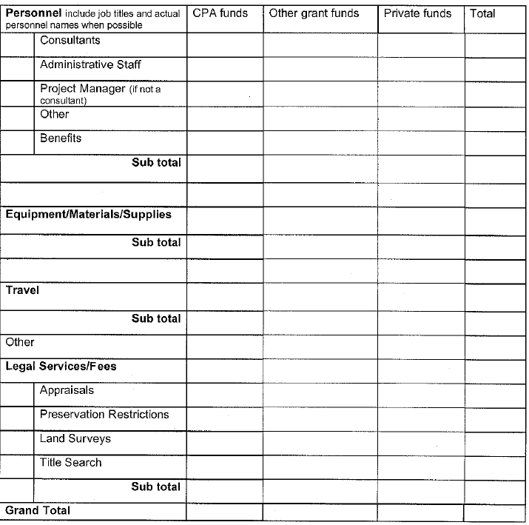

8
Appendix
Town of Hanson, Massachusetts
Community Preservation Committee

CPA Definitions:

Community housing: low and moderate income housing for individuals and families, including low or moderate income senior housing.

Historic resources: a building, structure, vessel or real property that is listed or eligible for listing on the state register of historic places or has been determined by the local historic preservation commission to be significant in the history, archaeology, architecture or culture of a city or town.

Low income housing: housing for those persons and families whose annual income is less than 80 per cent of the area-wide median income. The area-wide median income shall be the area-wide median income as determined by the United States Department of Housing and Urban Development
.
Low or moderate senior housing: housing for those persons having reached the age of 60 or over who would qualify for low or moderate income housing.

Moderate income housing: housing for those persons and families whose annual income is less than 100 per cent of the area-wide median income. The area-wide median income shall be the area-wide median income as determined by the United States Department of Housing and Urban Development.

Open space: shall include, but not be limited to, land to protect existing and future well fields, aquifers and recharge areas, watershed land, agricultural land, grasslands, fields, forest land, fresh and salt water marshes and other wetlands, ocean, river, stream, lake and pond frontages, beaches, dunes and other coastal lands, lands to protect scenic vistas, land for wildlife or nature preserve and land for recreational use.

Preservation: protection of personal and real property from injury, harm or destruction, but not including maintenance.
Maintenance: the upkeep of real or personal property.

Real property: land, buildings, appurtenant structures and fixtures attached to buildings or land, including, where applicable, real property interests.

Real property interest: a present or future legal or equitable interest in or to real property, including easements and restrictions, and any beneficial interest therein. (This is more specifically defined in the CPA law.)

Recreational use: active or passive recreational use including, but not limited to, the use of land for community gardens, trails, and noncommercial youth and adult sports, and the use of land as a park, playground or athletic field. Recreational use shall not include horse or dog racing or the use of land for a stadium, gymnasium or similar structure.

Rehabilitation: the remodeling, reconstruction and making of extraordinary repairs to historic resources, open spaces, lands for recreational use and community housing for the purpose of making such historic resources, opens spaces, lands for recreational use and community housing functional for their intended use, including but not limited to improvements to comply with the Americans with Disabilities Act and other federal, state or local building or access codes. With respect to historic resources, rehabilitation shall have the additional meaning of work to comply with the Standards for Rehabilitation stated in the United States Secretary of the Interior’s Standards for the Treatment of Historic Properties codified in 36 CFR Part 68.

Note: Taken from Chapter 44B of the Massachusetts General Laws, Community Preservation.

A
Town of Hanson, Massachusetts
Community Preservation Committee

Project Selection Criteria

The community preservation committee (CPC) shall make recommendations to the Hanson Town Meeting for the acquisition, creation and preservation of open space; for the acquisition, preservation, rehabilitation and restoration of historic resources; for the acquisition, creation and preservation of land for recreational use; for the creation, preservation and support of community housing; and for the rehabilitation or restoration of open space, land for recreational use and community housing that is acquired or created as provided in this section. With respect to community housing, the community preservation committee shall recommend, wherever possible, the reuse of existing buildings or construction of new buildings on previously developed sites.

Selection Criteria – All proposed projects must be eligible for CPA funding according to the requirements set forth in the law before further consideration can be given.

When a proposal meets the statutory requirements, the CPC will then rate projects using the following factors:

Requirements for all projects:

1. Consistency with the Hanson Master Plan, Open Space and Recreation Plan or other planning documents related to community preservation that have undergone a public planning process;

2. Support of a relevant town board/committee (Conservation Commission, Recreation Commission, Historic Commission, Hanson Housing Authority, Hanson Housing Partnership, Board of Selectmen, Master Plan, etc.);

3. Preserves a threatened resource;

4. Public access (if applicable to project);

5. Affordable cost;

6. Consistent with preservation program priorities (will not divert funding from a project with a higher priority).

Extra credit factors:

Serves more than one community preservation principle;

Project will have multiple funding sources /CPA funds can be leveraged to access other funds;

Acquisition project vs. development project (restoring, preserving or repairing as opposed to new development).

B
Town of Hanson, Massachusetts
Community Preservation Committee

Emergency Waiver of Time Process for Community Preservation Act Funding
All waivers are considered on a case-by-case basis and determined on their individual merits

Explanation:
In the event that a CPA eligible project cannot wait for the semi-annual application process, the applicant may at any time complete this waiver and submit it along with a pre-application to the Chair of the CPC. The determination to waive time requirements rests with the CPC. If the CPC gives permission for the application to circumvent the standard time schedules and the project is recommended by the CPC, the Town will be requested to hold a Special Town Meeting to vote on the proposal. Only after receiving a favorable majority from the Town and certification from the Attorney General and Department of Revenue will a project is awarded grant funds (private, non-governmental and non-profit organizations will still be subject to the deed restriction requirements and procedural steps which include a review of the proposal and deed by the State Historical Commission).

Circumstances which may be considered for such a waiver include, but are not limited to, historical property damaged by an “act of God” not covered by insurance and the lack of attention to which would cause irreparable damage to the structure; land offered for sale which has been given priority status by the CPC and on which the Town has first right of refusal but insufficient funds to purchase; land offered for sale which has been given priority status by the CPC and which the town does not wish to purchase with general funds; a grant which for which CPA funds would leverage monies, but the application for which is due before the regular CPA grant cycle, etc.

Evidence of the emergency status prompting the waiver must be presented in a convincing and thoroughly documented manner at the time of application.

Projects which have been denied waivers are allowed to present their proposals during the regularly scheduled bidding in that funding year providing that they receive a positive result from a pre-application.

Once a project has been denied a waiver, it may not apply for another waiver or submit a standard application in that funding year.

All recommendations of the CPC are final.

The applicant should note that because “emergency waivers” cannot waive standard CPA protocols (town meeting, AG and DOR approval, etc.), a 3-4 month period will probably elapse after application before funding is available.

Waiver

Project Name___________________________________________________________________________________

Applicant_______________________________________________________________________________________

Amount of Funding Requested____________________________________________________

Reason(s) Waiver is Requested (2 page limit) _______________________________________

Be specific, clear and concise in the description of the emergency that exists and necessitates this waiver. If this waiver is denied, you may not apply for CPA funds for this project in this funding year.

If this waiver is denied, will you request CPA funds during the regular funding cycle?

􀀀 Yes 􀀀 No Explain_________________________________________________________________________

This form along with either a pre-application or a pre-application and full application must be submitted to the Chair of the Hanson CPC. If only a waiver form and pre-application are submitted, a full application must be forthcoming upon approval. No recommendation will be made to the Town until a full proposal is approved.by the Community Preservation Committee:
C
Town of Hanson, Massachusetts
Community Preservation Committee
Deed Restrictions

If your organization is non-governmental, privately owned or non-profit, there will be a deed restriction placed on your property as a condition of accepting CPA funding for preservation or reconstruction. A deed restriction will limit your future use of the property in perpetuity, e.g., the façade of a building must remain and be maintained according to historic preservation regulations, open space may not be developed for commercial use, etc. If you have questions about a deed restriction, you are welcome to call the Committee Chair for further explanation or discussion before submitting an application for funding.

The following information is necessary for the deed restriction and will need to be submitted to the CPC before a deed restriction is completed. This information is NOT required with the funding application but will be required if the proposed project is accepted by the Town of Hanson to receive CPA funds:

- A copy of your organization's by-law [or other legal documentation] setting forth who is authorized to deal with property, i.e., execute deeds, mortgages, easements, restrictions, vote, etc.
2. A full and complete description of the building [or property] as to what it is made of, what it consists of, size, shape, who designed it, when it was constructed, etc.
3. A full description of what makes the building [or property] historical and why it is so designated.
4. A copy of the deed---book and page where recorded. [Deeds are available at the Registry of Deeds in Plymouth]
5. Exterior photographs of the building [or property].
6. A copy of the Hanson Assessor's map showing your property.
7. Copies of As-build plot plan and As-Built drawings of the building if they exist.
8. Insurance Certificate
9. Documentation of any prior restrictions, historical or otherwise on the building [or property].

The following is an example of answers to #’s 1, 2 and 3 above from a Preservation Restriction Agreement with the Unity Church of North Easton, Unitarian Universalists

- Authority to sign.
The Preservation Restriction Agreement with the Easton Historical Commission was granted by the building trustees of the Unity Church of North Easton, Unitarian Universalists. Apparently, the Trustees have the authority to deal with real estate.

- Description of the Building.
As an example, the above church was described as follows: The building is a granite, gothic revival church with a stone bell tower that has a stone roof. The balance of the building has a decorative slate roof, topped with iron cresting at its peak. The building contains world-renowned stained glass windows. The building was designed by John Ames Mitchell (1845-1918) and constructed in 1875 with funding from Oliver Ames, Jr. (1807-1877). The building serves as a church for Unity Church of North Easton Unitarian Universalist.

- Historical significance.
As an example, the same church was described as follows: The historical significance of the building emanates from its construction in 1875, its location within the North Easton National Register Historic District (designated November 3, 1972) and its architectural and artistic design and numerous significant contents including stained glass windows by John Lafarge, windows which have worldwide artistic significance and interior woodwork by Johann Kirchmayer. Additionally, the building is listed as a contributing property to the North Easton National Register Historic District and is important to the public enjoyment and appreciation of its architectural and historical heritage.

D
Town of Hanson, Massachusetts
Community Preservation Committee

PROCEDURAL STEPS TO BE TAKEN RE: PRIVATE ORGANIZATIONS AND HISTORICAL PRESERVATION RESTRICTIONS

The Hanson Community Preservation Committee requires that a historic preservation restriction be placed on buildings, other structures or land in which the CPA makes a funding investment. Therefore, after the town meeting has voted to award CPA funds to a private organization or entity, the following process will take place before funds are awarded.

1. Drafting of the Preservation Restriction Agreement by the Hanson Town Counsel at the applicants expense.

2. Review of and final approval draft Preservation Restriction Agreement by the Community Preservation Committee (CPC).

3. Review of its individual Preservation Restriction Agreement by the organization that will be signing the same as a contingency of receiving CPA funding.

4. Submission of “Items Required”, i.e., historical information; description of what makes the building or property historical; a copy of the property’s deed; a copy of the Assessor’s Map; as-build plot plans and as-built drawings of the building if in existence, by the organization seeking to receive CPA funds and:

a. A copy of the organization’s by-law setting forth who is authorized to deal with and execute a Preservation Restriction Agreement on the organization-owned property.

b. A copy of the organization’s legal document defining who is currently authorized to vote for the organization.

5. Once the Agreement is prepared and in final form for signatures, it must be executed by the organization receiving CPA funding, forwarded to the Massachusetts Historical Commission for approval and upon return from the Mass. Historical Commission it must be approved by both the Hanson CPC and the Hanson Board of Selectmen.

6. After approval by all entities, the fully executed Agreement must be recorded in the Plymouth County Registry of Deeds.

7. Presuming that the Hanson CPC has seen and reviewed the plans, drawings, specifications, etc. for the project, that it has recommended the project for funding and that the Town of Hanson through its town meeting has voted to approve such funding, CPA funds may after the approval and recording of the deed restriction, be released for the project.

E

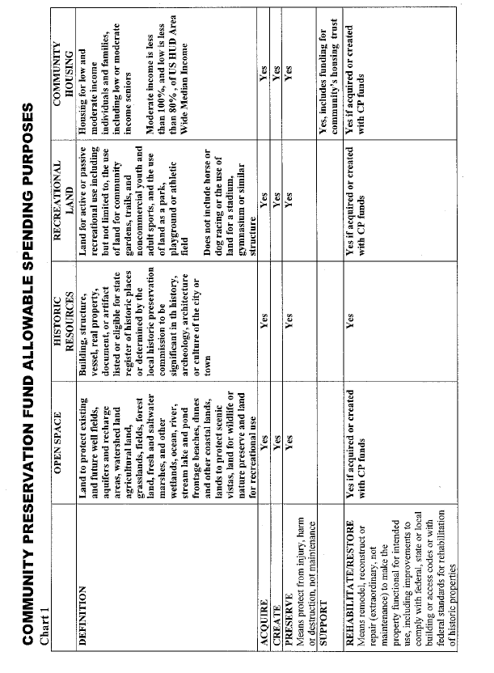
F

Town of Hanson, Massachusetts
Community Preservation Committee
Scoring Criteria:

Basic Requirements 100 Points Possible

Responsiveness to recommendations in pre-application response...... 5 points

Completion of Project Description/ Eligibility for Funding..................... 5 points

Completion of Considerations for Funding........................................... 5 points

Project Narrative (50 points)

History and current status of applicant agency................................ 5 points

Project description......................................................................... 10 points

Time-task plan................................................................................. 5 points

Project management task plan....................................................... 10 points

Alignment of project with other town priorities................................. 5 points

Letter(s) of support.......................................................................... 5 points

Memorandum of Agreement............................................................. 5 points

Benefit to Hanson...................................................................... 5 points

Budget Sheet/Budget Narrative (35 points)

Job descriptions and personnel résumés....................................... 10 points

Well defined, reasonable request.................................................. 10 points

Assurance of non-burden to town................................................... 5 points

Proof of due process for cost estimates.......................................... 5 points

Ability to leverage other funds......................................................... 5 points

Bonus Points

Serves more than one community preservation principle.............. 10 points ea

Additional Memoranda of Agreement............................................ 10 points ea

Proof of fulfilling a formally recommended project from another

Hanson board/committee/commission.......................................... 10 points

Ability to leverage funds from more than one source.................... 10 points

Acquisition project rather than development project...................... 10 points

G
Application Final Check List — Applications must be submitted in this order:

- Cover Page

- Project Description/ Eligibility for CPA Funding (application pages 3-4)

- Considerations for Funding (application pages 4-6)

- Project Narrative (3 page limit)

- Overall responsiveness to pre-application recommendations

- Thorough, well defined presentation of the project

- Budget Sheets (application page 8)

- Budget Narrative (2 page limit)

- Include job descriptions

- Memorandum of Understanding

- Signed for hard copies/unsigned on letterhead for electronic version

- Letters of Support

- Signed for hard copies/unsigned on letterhead for electronic version

- Other attachments (photos of historic buildings, site maps, etc.)

When the package is complete in the order required do not forget to send

One original full application packet and 9 hard copies to Hanson Town Hall (hand delivered or sent via mail)

H

